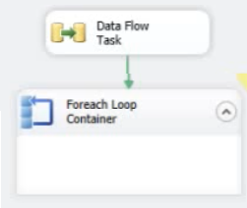

Load recordet into Object variable **MyData**

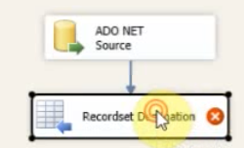

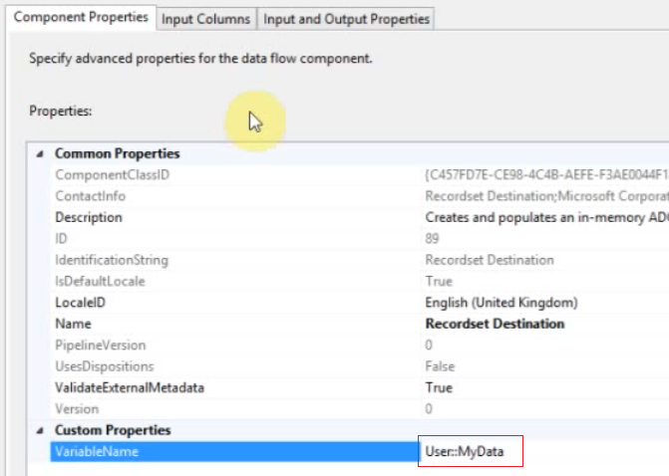

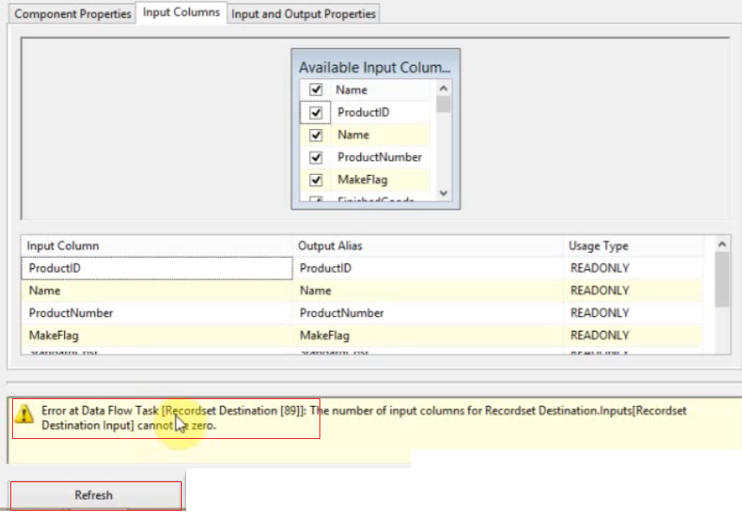

To avoid the error click refresh

In the foreach use

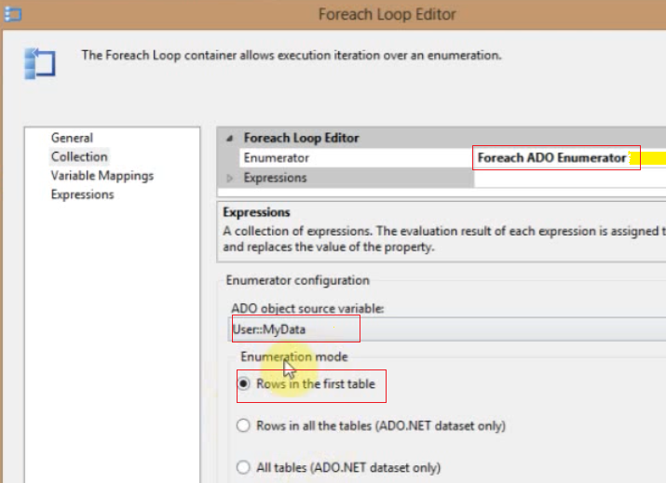

Or get all the information in the script

Let use for Recordset store in variable Error_Missing1

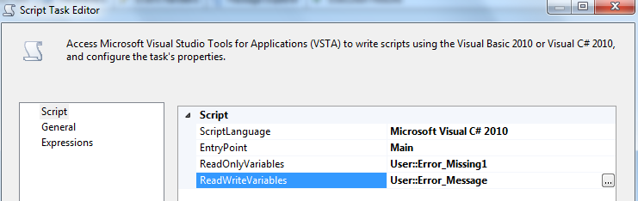

The script

Dts.TaskResult = (int)ScriptResults.Success;

OleDbDataAdapter oleDA = new OleDbDataAdapter();

DataTable dt = new DataTable();

DataColumn col = null;

DataRow row = null;

string strMsg = null;

oleDA.Fill(dt, Dts.Variables["Error_Missing1"].Value);

foreach (DataRow row_ in dt.Rows)

{

row = row_;

foreach (DataColumn col_ in dt.Columns)

{

col = col_;

strMsg = strMsg + col.ColumnName + ": " + row[col.Ordinal].ToString() + Environment.NewLine;

}

}

MessageBox.Show(strMsg);

if (strMsg !="") Dts.Variables["Error_Message"].Value = "Errores "+ strMsg;

Dts.TaskResult = (int)ScriptResults.Success;